**Demo**

1. **Start server**

Command: python main.py -root_document “/” -port 8090

As we can see above, the file directory on my server is **“/”**. If a file in it, my server will return it. Otherwise, my sever will return **404** error. Besides, if a file is in the other directory rather than the file directory **“/”**, my server will return 403 error.

1. **The structure of server**

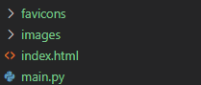

I have my server tested on the codespace of github which creates a new address in my browser that is equivalent to http://localhost:port/

1. **Homepage**

http://localhost:8090/



Fig 1 homepage

http://localhost:8090/index.html



Fig 2. homepage

1. **400 error page**

To get this kind of error, we need to visit a file that does not exist under the file directory “/”. Here is the link: http://localhost:8090/filename

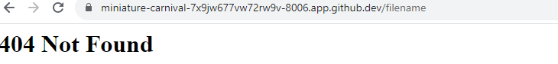

Fig 1. 404 error

1. **403 error page**

To get this kind of error, we need to visit a file that exist under other file directory rather than the directory “/. Here is the link: http://localhost:8090/filename

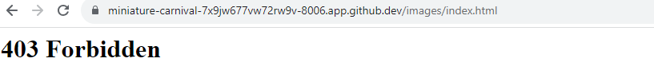

Fig 2. 403 error